**Stock Price Trend Prediction with LSTM**

**1. Introduction**

The stock market is inherently volatile and influenced by numerous unpredictable factors. Accurate trend forecasting is a crucial task in the domain of financial analytics. This project aims to predict stock price trends using Long Short-Term Memory (LSTM) neural networks — a type of recurrent neural network (RNN) particularly effective at modeling sequential data.

**2. Tools and Technologies**

* **Language & Libraries**: Python with pandas, numpy, yfinance, scikit-learn, ta, and tensorflow
* **Frontend**: Streamlit dashboard for real-time interactive prediction and visualization
* **Model**: LSTM model trained using historical stock prices
* **Deployment**: Local or cloud-hosted Streamlit application

**3. Data Acquisition and Preprocessing**

Stock data is pulled from Yahoo Finance using the yfinance API for the last two years. The features used include:

* Open, High, Low, Close, and Volume prices
* Derived indicators: Moving Average (MA), Relative Strength Index (RSI), and MACD

To ensure consistent scaling for LSTM input, data is normalized using MinMaxScaler. A sliding window of the last 60 days is used to predict the next day's price.

**4. Model Architecture**

The LSTM model, stored in model_weights.h5, is designed to capture temporal dependencies. Key features:

* One or more LSTM layers to handle sequential patterns
* Dense output layer for predicting a single future price
* Trained using MSE loss and Adam optimizer

The model is trained on closing prices to predict the trend of future prices.

**5. Streamlit Dashboard Overview**

The application provides a user-friendly interface to:

* Enter a stock ticker symbol (e.g., AAPL)
* Select the number of days to predict (1–30)
* Visualize:
  + **Historical stock prices** (Open, High, Low, Close)
  + **Trading volume**
  + **50-Day Moving Average with Close price**
  + **RSI & MACD indicators**
  + **Predicted future prices** alongside historical prices

**Example Visualization**

Here’s a sample stock chart as generated by the dashboard:

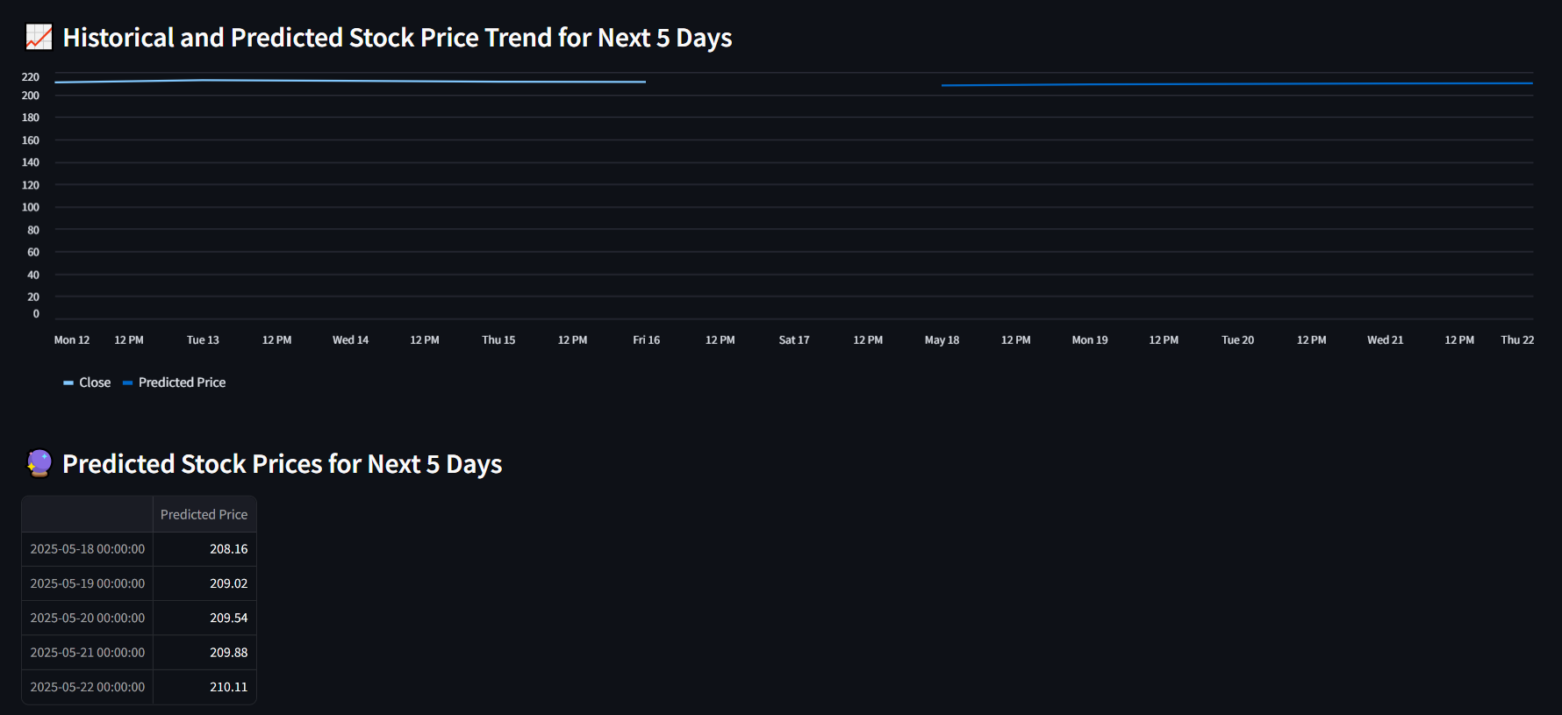

**Figure**: Historical and Predicted Stock Price Trend

**6. Prediction Workflow**

1. The app takes the last 60 days of closing prices.
2. Normalizes the data and reshapes it to the model’s input format.
3. Predicts the next *n* days sequentially by feeding the model its own previous output.
4. The predictions are then reverse-scaled and plotted.

**7. Output and Trading Signal**

Alongside numerical predictions, the app computes a trading signal:

* **Buy**: If price is expected to increase by more than 1%
* **Sell**: If price is expected to drop by more than 1%
* **Hold**: Otherwise

These signals are derived from comparing the last real close price to the first predicted price.

**8. Conclusion**

This project effectively combines deep learning with a simple, intuitive UI to provide real-time stock price trend forecasts. While the LSTM model shows promising results, users are advised to treat these predictions as educational tools rather than financial advice.

**9. Future Work**

* Incorporate more features like news sentiment or macroeconomic indicators.
* Improve model performance through hyperparameter tuning or alternative architectures (e.g., GRU, Transformer).
* Deploy as a cloud-hosted application with user authentication and portfolio tracking.

**Developer**: Shreyas Meru  
🌐 Website: [shreyas-meru.web.app](https://shreyas-meru.web.app/)